- ARRAY SUM

AIM:

To create a sum of the array usinf the template function.

ALGORITHM:
· Define a function template to calculate the sum of array elements
· Initialize a variable sum to zero inside the function
· Use a loop to traverse each element of the array
· Add each array element to sum
· Return the final value of sum
· In main() declare an integer array and call the template function
· Display the sum of the integer array
· Declare a float array and call the same template function
· Display the sum of the float array
· Declare a double array and call the same template function
· Display the sum of the double array

PROGRAM:

/*
* Program to caluculate sum of array in template
* Author : MUTHUGANESH S
* Date : 3/2/2026
* Filename: ArraySum.cpp
* retval : void
*/

#include <iostream>
using namespace std;

// template function definition
template <typename T>

// Function to calculate sum of array elements
T ArraySum(T Array[], int Size) {
T sum = 0;
for (int i = 0; i < Size; i++) {
sum += Array[i];
}
return sum;
}

int main(){

//Integer array
int IntArray[] = {1, 2, 3, 4, 5};
cout<<"Sum of Integer Array : "<<ArraySum(IntArray, 5)<<endl;

//Float array
float FloatArray[] = {1.1, 2.2, 3.3, 4.4, 5.5};
cout<<"Sum of Float Array : "<<ArraySum(FloatArray, 5)<<endl;

//Double array
double DoubleArray[] = {1.11, 2.22, 3.33, 4.44, 5.55};
cout<<"Sum of Double Array : "<<ArraySum(DoubleArray, 5)<<endl;

return 0;
}

OUTPUT:

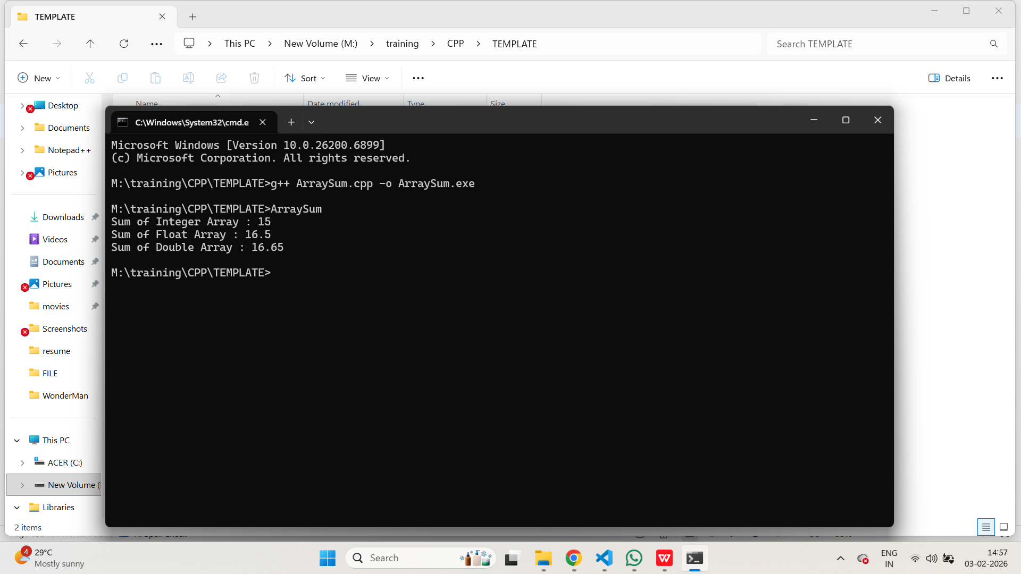

- SIMPLE CALCULATOR

AIM:

To create a class template for the simple calculator program.

ALGORITHM:
· Define a class template with functions for add, subtract, multiply, and divide
· In main(), create calculator objects for int, float, and double
· Initialize values for each data type
· Perform all arithmetic operations using integer values and display results
· Perform all arithmetic operations using float values and display results
· Perform all arithmetic operations using double values and display results

PROGRAM:

/*
* Program to create a simple calculator using templates
* Author : MUTHUGANESH S
* Date : 3/2/2026
* Filename: SimpleCalculator.cpp
* retval : void
*/

#include <iostream>
using namespace std;

// Template class definition
template <class T>

// Simple Calculator class
class Calculator {
public:
T Add(T a, T b) {
return a + b;
}

T Subtract(T a, T b) {
return a - b;
}

T Multiply(T a, T b) {
return a * b;
}

T Divide(T a, T b) {
return a / b;
}
};

int main() {

Calculator<int> calcInt; // Integer Calculator object
Calculator<float> calcFloat; // Float Calculator object
Calculator<double> calcDouble; // Double Calculator object

int a = 10, b = 5;
float c = 10.5, d = 5.5;
double e = 10.55, f = 5.55;

cout << "Integer Addition: " << calcInt.Add(a, b) << endl;
cout << "Integer Subtraction: " << calcInt.Subtract(a, b) << endl;
cout << "Integer Multiplication: " << calcInt.Multiply(a, b) << endl;
cout << "Integer Division: " << calcInt.Divide(a, b) << endl;

cout << "\nFloat Addition: " << calcFloat.Add(c, d) << endl;
cout << "Float Subtraction: " << calcFloat.Subtract(c, d) << endl;
cout << "Float Multiplication: " << calcFloat.Multiply(c, d) << endl;
cout << "Float Division: " << calcFloat.Divide(c, d) << endl;

cout << "\nDouble Addition: " << calcDouble.Add(e, f) << endl;
cout << "Double Subtraction: " << calcDouble.Subtract(e, f) << endl;
cout << "Double Multiplication: " << calcDouble.Multiply(e, f) << endl;
cout << "Double Division: " << calcDouble.Divide(e, f) << endl;

return 0;
}

OUTPUT:

